

**User Guide**



Table of Contents

Introduction 2

Dream House operations: 2

Dream House software has three main operations. 2

System Requirement 2

Installation Procedure 2

Step 1: Click the CD/DVD rom drive. 3

Step 2: Click the installer file. 3

Step 3: Setup Screen will pop up>Click Next to continue. 4

Step 4: Select installation path 4

Step 5: Select installation folder 5

Step 6: Select desktop shortcut icon option

Step 7: Ready to install 6

Step 8: Finish installation 6

Step 9: Setup Database file 7

Alternative way of inserting Database: 7

Un-install Dream House: 8

Step 1: Confirmation of Un-installation 8

Step 2: Progress of Un-installation 8

Step 3: Successfully Removed 8

Run Dream House: 9

Agent/User Log in: 9

Welcome Page: 10

Search Result Page: 11

About-Us Screen: 12

Admin Log in: 12

Admin Welcome Screen: 13

Add new property (Admin): 15

Edit/Update property (Admin): 16

About-Us Screen: 17

# Introduction

Dream House is desktop based software made for the real estate agent to sell the listed property they have. It has been developed to promote standard solution for all Windows and UNIX vendors and users. Dream House provides Graphical User Interface to operate its features.

## Dream House operations:

Dream House software has three main operations.

1. It allows administrator to insert the property i.e. Apartment, House, Condo etc.
2. It allows Agent/User and Administrator to search the property listed through selected filter(s) i.e. Price, Size, Location etc.
3. It allows the administrator to edit or delete the property listed.

## System Requirement

Operating System : Windows/LINUX (Fedora/Ubontu)

Database : Oracle Db11g

Processor speed : Core 2 Duo

RAM : Minimum 1 GB

Hard disk : 100 MB or above

## Installation Procedure

To install Dream House into computer insert the installer CD/DVD into CD/DVD

ROM Drive. If you download that installer leave this step.

### Step 1: Click the CD/DVD rom drive.

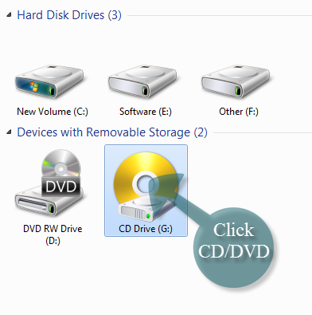

### Step 2: Click the installer file.

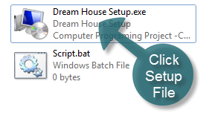

To install the Dream House software double-click the ‘Dream House Setup.exe’ file. Before installing that software you need to make sure that no other files are in installation process. However, make sure that all the requirement has been fulfilled.

Step 3: Setup Screen will pop up>Click Next to continue.

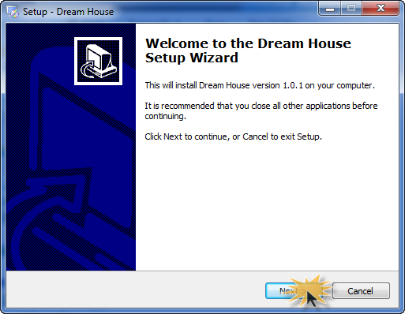

Step 4: Select installation path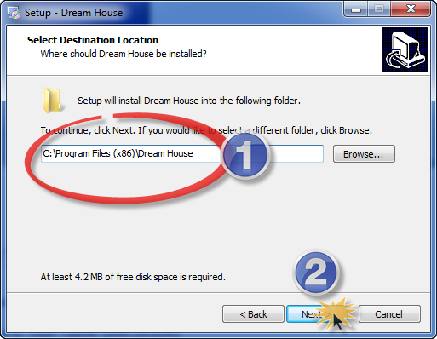

1. If you would like to select different folder to install Dream House click browse and select that folder. Default folder is Program Files.
2. To continue, click next. It will select the default path.

### Step 5: Select installation folder

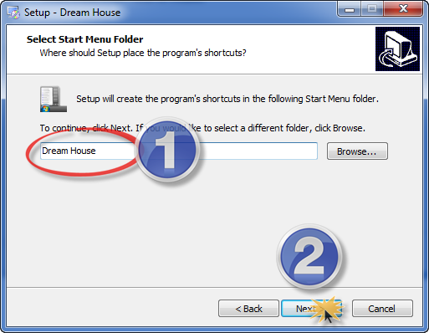

1. IF you would like to select different folder, click Browse.
2. To continue, click next with default Name of folder.

Step 6: Select desktop shortcut icon option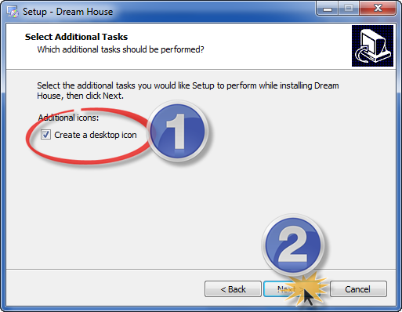

1. Click check box ‘Create a desktop icon’ if you want to have a shortcut icon for Dream House
2. Click next, to continue with default set up.

### Step 7: Ready to install

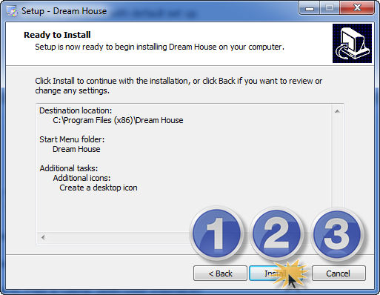

1. To change anything click ‘Back’ button. Follow Step 1-6 after that.
2. To cancel click ‘Cancel’ button any time.
3. Click install to install Dream House.

### Step 8: Finish installation

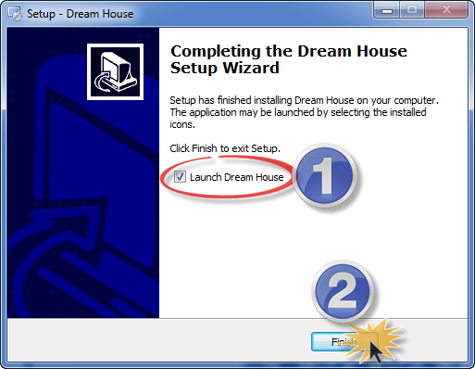

1. Check ‘Launch Dream House’ if you want to start using Dream House now.
2. To continue, click Finish with default selection

**Short Cut Icons**

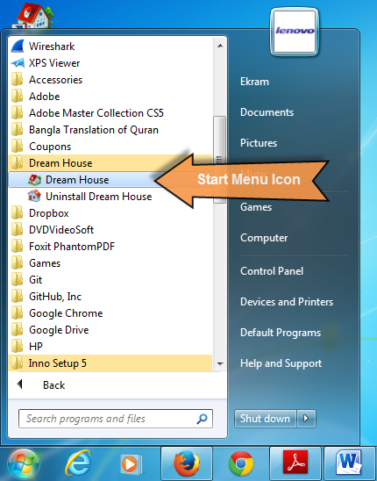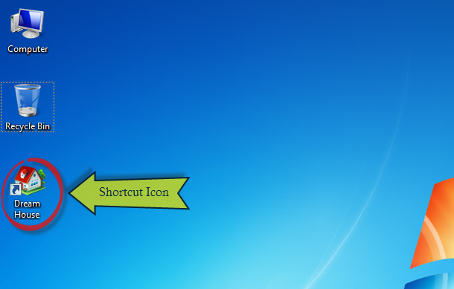

### Step 9: Setup Database file

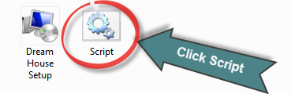

## Alternative way of inserting Database:

Assumed that Oracle database 11 g has already been installed.

Click . Copy those SQL and run that into Oracle Script. The connection name should be ‘orcl’ and password should be ‘sysman123’.

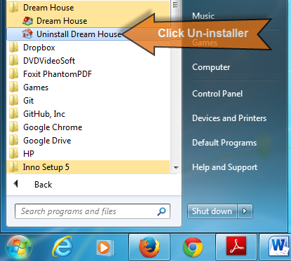

## Un-install Dream House:

## To un-install the Dream House software, if you to go to the

## start menu and click the ‘Uninstall Dream House’.

### Step 1: Confirmation of Un-installation

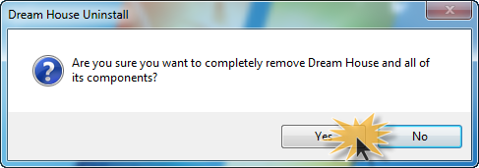

### Step 2: Progress of Un-installation

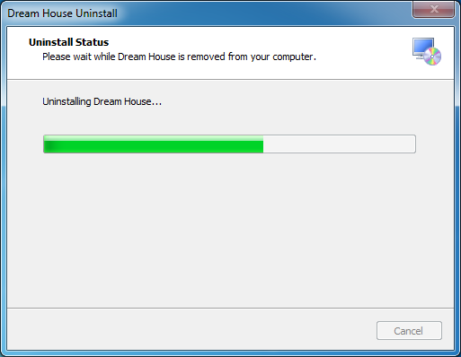

### Step 3: Successfully Removed

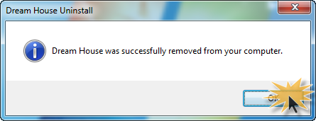

## Run Dream House:

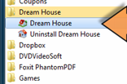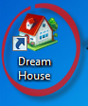Go to start menu and click Dream House icon under Dream House folder. Or click the desktop icon.

## Agent/User Log in:

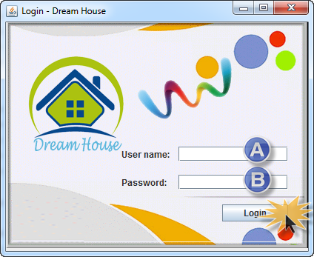

1. Enter user name here. Default user name is ‘user’.
2. Enter password here. Default password for user is ‘user123’.

If you enter wrong user name or password, it will show

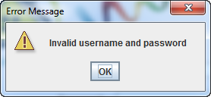

User can be created by the Database Administrator.

## Welcome Page:

After log in successfully user will see the screen of welcome. Welcome page is actually a search page where user puts its criterion to get a desired result from the database.

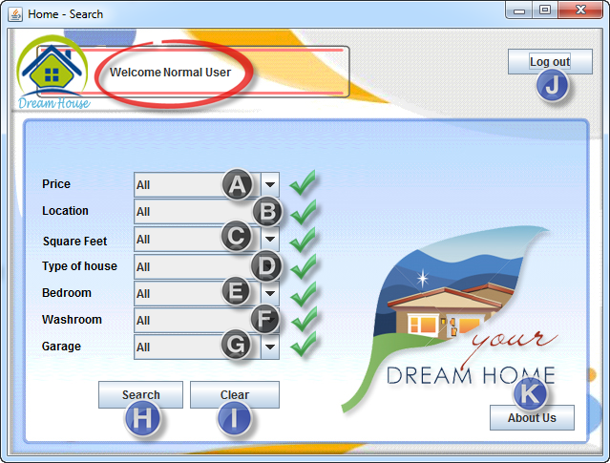

A) User can search the property by filtering the price range by selecting the price drop down menu.

B) User can search the property by filtering the Location by selecting Location drop down menu.

C) User can search the property by filtering the Square feet of the property by selecting the Square feet drop down menu.

D) User can search the property by filtering type of house.

E) User can search the property by filtering the number of bed room.

F) User can search the property by filtering the number of wash room.

G) User can search the property by filtering the number of garage.

H) Click ‘Search’ button to search the filtered property.

I) Click the ‘Clear’ button to clear all the selection.

J) Click the ‘Log Out’ button to log out from the system.

K) Click ‘About us’ button to see the about us screen.

## Search Result Page:

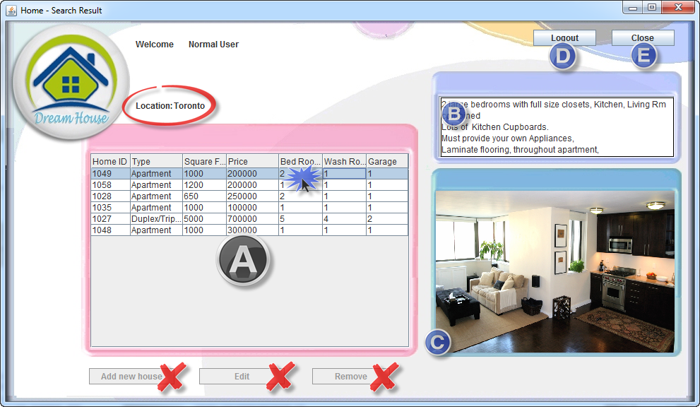

A) After filtering the price, location, size, type of house, number of bedroom, washroom and garage, user will see the result of the property. When user clicks it part B and C will appear.

B) By clicking the property listed user can see the detail of that particular property.

C) By clicking the property user can see the picture of that property.

D) Click ‘Log out’ button to log out from the search result page.

E) Click ‘Close’ button to close current page.

‘Add new house’, ‘Edit’ button, ‘Remove’ button is not enabled for user. Only Admin user can access those button.

## About-Us Screen:

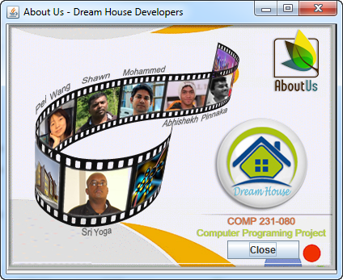

User can see the ‘About us’ Page by clicking the ‘About us’ button from the Welcome Page.

## Admin Log in:





1. Enter Admin user name here. Default user name is ‘admin.
2. Enter admin password here. Default password for user is ‘admin123.

If you enter wrong user name or password, it will show

## Admin Welcome Page:

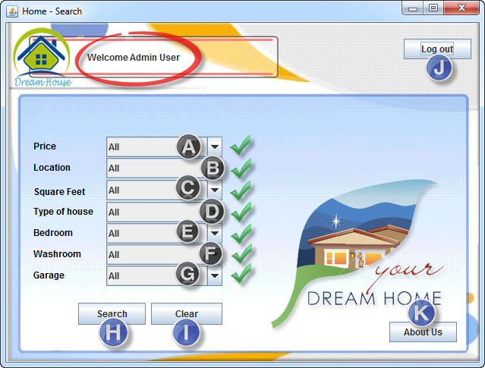

A) Admin user can search the property by filtering the price range by selecting the price drop down menu.

B) Admin user can search the property by filtering the Location by selecting Location drop down menu.

C) Admin user can search the property by filtering the Square feet of the property by selecting the Square feet drop down menu.

D) Admin user can search the property by filtering type of house.

E) Admin user can search the property by filtering the number of bed room.

F) Admin user can search the property by filtering the number of wash room.

G) Admin user can search the property by filtering the number of garage.

H) Click ‘Search’ button to search the filtered property.

I) Click the ‘Clear’ button to clear all the selection.

J) Click the ‘Log Out’ button to log out from the system.

K) Click ‘About us’ button to see the about us screen.

## Admin Search Result Screen:

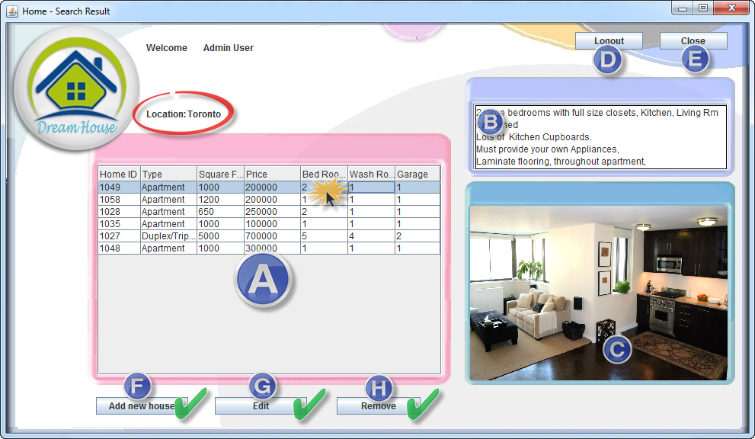

A) After filtering the price, location, size, type of house, number of bedroom, washroom and garage, Admin user will see the result of the property. When user clicks it part B and C will appear.

B) By clicking the property listed user can see the detail of that particular property.

C) By clicking the property user can see the picture of that property.

D) Click ‘Log out’ button to log out from the search result page.

E) Click ‘Close’ button to close current page.

F) Click ‘Add new house’ button to add a property to the list.

G) Click ‘Edit’ button to edit or update a property listed.

H) Click ‘Remove’ button to remove a property from the property listed.

F, G, H are the only the accesses for Admin user only.

## Add new property (Admin):

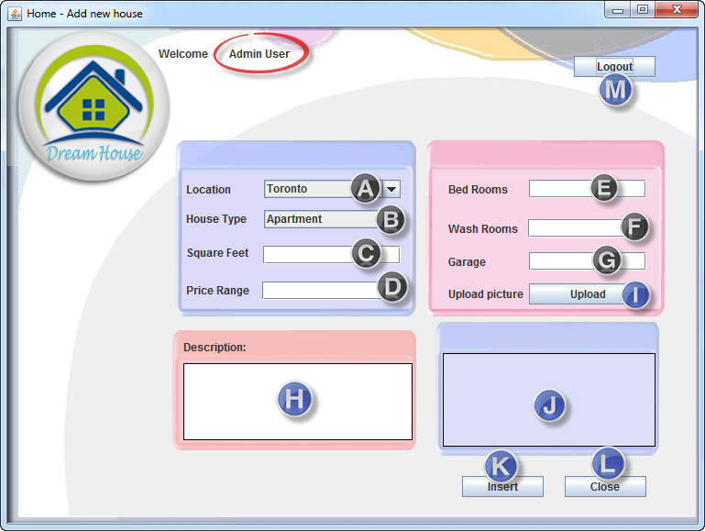

A) Admin user can add the location by selecting area from drop down menu.

B) Admin user can add the type of the house from the ‘House Type’ drop down menu.

C) Admin user can add number of Square feet of the property.

D) Admin user can add the price of the property.

E) Admin user can add the number of bed room of the property.

F) Admin user can add the number of wash room of the property.

G) Admin user can add the number of garage room of the property.

H) Admin user can add the Description of the property.

I) Admin user should add the picture of the property which is mandatory field.

J) When a picture is added Admin user can see that in part J.

K) Click the ‘Insert’ button to add a property into the system.

L) Click ‘Close’ button to close ‘Add New House’ page.

## Edit/Update property (Admin):

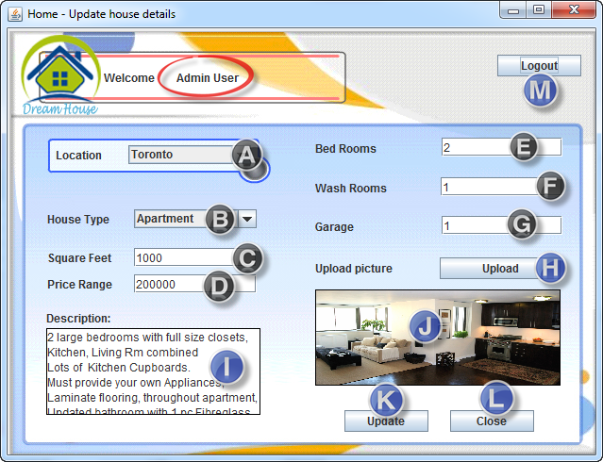

A) Admin user can edit/update the location by selecting area from drop down menu.

B) Admin user can edit/update the type of the house from the ‘House Type’ drop down menu.

C) Admin user can edit/update number of Square feet of the property.

D) Admin user can edit/update the price of the property.

E) Admin user can edit/update the number of bed room of the property.

F) Admin user can edit/update the number of wash room of the property.

G) Admin user can edit/update the number of garage room of the property.

H) Admin user can edit/update the Description of the property.

I) Admin user should edit/update the picture of the property which is mandatory field.

J) When a picture is edited/updated Admin user can see that in part J.

K) Click the ‘Insert’ button to edit/update a property into the system.

L) Click ‘Close’ button to close ‘Update House’ page.

## About-Us Screen:



This ‘About us’ page will show the list of the developer. User or Admin can close the page by closing the button ‘Close’.